# INTRODUCTION

Overview

* + The iPhone's touchscreen was a major innovation in the smartphone industry. It was more responsive and accurate than the resistive ones used in earlier mobile devices. The capacitive touchscreen allowed users to interact with their phones in a whole new way, using gestures such as swipe, tap, and pinch to zoom.
  + The parts that went into the iPhone and other smartphones — tiny cameras, dense batteries, high-quality touch screens — were cloned and eventually became common, enabling a generation of entrepreneurs to make new kinds of hardware products, such as drones, scooters and smart home products.
  + Apple's decision to manufacture iPhones in India is a robust alignment with the Indian government's 'Make in India' initiative. By engaging local suppliers like Foxconn and Wistron, Apple is contributing to the nation's industrial growth, inculcating technological innovation, and creating thousands of jobs.

Purpose

* It allowed people to access information through digital media on their phones. Apple's iPhone is an amazing invention that allows users to get all of their needs done in one device. Apple's iPhones are not only used for entertainment purposes but they can be used for business purposes.
* The most significant development since the iPhone's invention is the ability to keep everything in one place. Your calls, texts, emails, photos, videos, music, calculators, maps, GPS, games, and more are now in a single device. However, most users today use cloud-based apps and storage for more features and security.
* By facilitating better communication, mobile phones save us time. They allow us to reach whoever we need whenever we need. If you are looking for a quick way to contact someone, a mobile phone is an answer.People are 4.5 times more likely to respond to a text than an email.
* There's even a so-so phone on there. Mobile phones had limited Internet access before the iPhone, but the device's browser was a huge improvement, displaying webpages more like they actually looked on a desktop computer.

**Problem Definition & Design Thinking**

* 1. Empathy Map

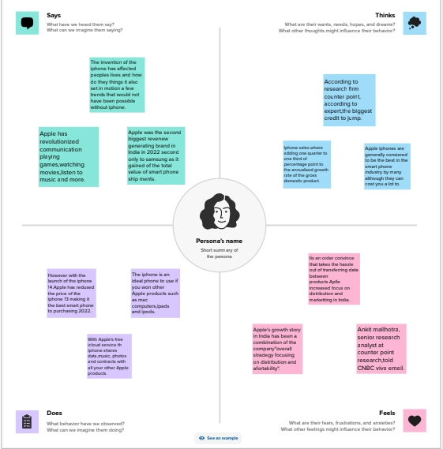

* 1. Ideation & Brainstorming Map

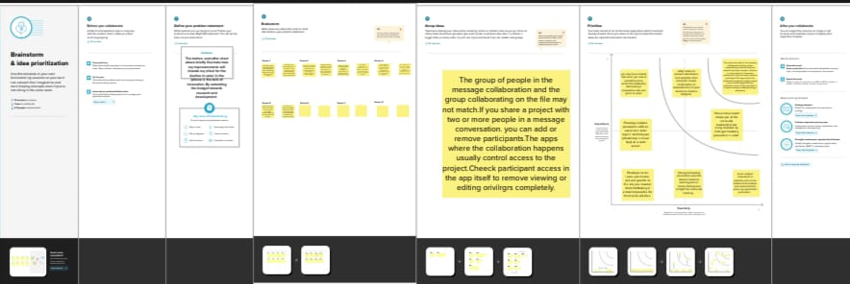

# RESULT

# 

# ADVANTAGES

* User-Friendly Interface: The iPhone has an intuitive user interface that makes it easy to navigate. The touch screen interface is easy to use, and the iPhone's smooth operating system is simple to learn and use. 2. High-Quality Display: The iPhone's Retina display is one of the best in the market.
* The iPhone has many advantages. For which users do not want to shift to other brands of devices. Notable among these are long time software update facility, security, eye-catching design, performance. Below are some more features and benefits of the iPhone was highlighted.
* The iPhone is an ideal phone to use if you own other Apple products, such as Mac computers, iPads and iPods. With Apple's free iCloud service, the iPhone shares data, music, photos and contacts with all your other Apple products. It's an added convenience that takes the hassle out of transferring data between products.

**DISADVANTAGES**

* Cost: The iPhone is one of the most expensive smartphones on the market.
* Non-Removable Battery: The iPhone's batteries are non-removable, which means that users cannot replace them.
* Limited Customization: One of the disadvantages of the iPhone is that it has limited customization options.
* I phones are very expensive the call log entries are limited to 2 days OR 100 entries in total - where as an android phone stores unlimited call log biggest limitation - there is no t-9 dialer in I phone, which means you have to go to the contacts and search for a name to dial
* moving music or videos to an I phone is a nightmare - almost requiring engineering skills
* you cannot replace battery + any repairing is very expensive there is no back button - which is so very handy in android.
* Despite its dominance in the space of mobile devices and computing, the company does face some key challenges. Among these weaknesses are its highly-priced products, entering areas of higher competition, and incompatibility with other software.

# APPLICATIONS

* + The iPhone reinvented the idea of mobile gaming. Apps like Angry Birds, that anyone could play using their fingers on the touchscreen, became hugely popular, and payment models changed.
  + The iPhone Has Changed the Way We Communicate.
* All of these methods allow us to connect with others quickly and easily. Before the first iPhone hit the market, a few cell phone companies put cameras in their phones, but the cameras used in these iPhones were head and shoulders above the rest.
  + Apple's iPhone was a great success because it made communication more convenient than ever before. It allowed people to access information through digital media on their phones. Apple's iPhone is an amazing invention that allows users to get all of their needs done in one device.
  + We've more than tripled the amount of renewable electricity in our supply chain since 2019. And as the first Apple product built with 100% clean electricity, Apple Watch is a milestone in our transition to clean electricity for manufacturing. By 2030, Apple Watch will be joined by every Apple product.

# CONCLUSION

* With the iPhone you get better quality and better security when dealing with your personal information. Innovation and technological advancements have keep the iPhone and Apple ahead of its competitors in this tight notch market. With the iPhone being so popular and in high demand, estimated shortages are suspected.
* Apple and the IPhone is a great example of a corporation making what the consumer wants in a global market. With limited companies competing, competition for the best phone on the market is at an all-time high.
* The iPhone provided a new way of mobile phone communication and usability. Its revolutionary technology has led to the variety of smartphones that are in use today.

# FUTURE SCOPE

# In the short term, we’re likely to see incremental improvements like higher quality cameras and giant displays. But over the next decade, the iPhone could evolve into a hub for smart glasses and other devices.

# But in the future, the most important part of the iPhone might be everything around it. That's according to analysts who've observed the mobile industry's general trends and Apple's strategy. In the short term, we're likely to see incremental improvements like higher quality cameras and giant displays.

# APPENDIX

1. Source code

https://public.tableau.com/app/profile/priyadharshini.m5915/viz/URCWTeam6Iphoneimpact_16974455612240/Story1?publish=yes#WelcomeQuestionnaire

